Why 6? More or less. Trying with different or less.
Variance explained

This document summarizes the application of the analytical framework from Tsuboi et al. (2026) “Variation evolves, but its ability to predict macroevolution persists” to the simian phenotypic covariance matrices. The objective is to evaluate whether the same patterns observed in the original study are recovered in this dataset.

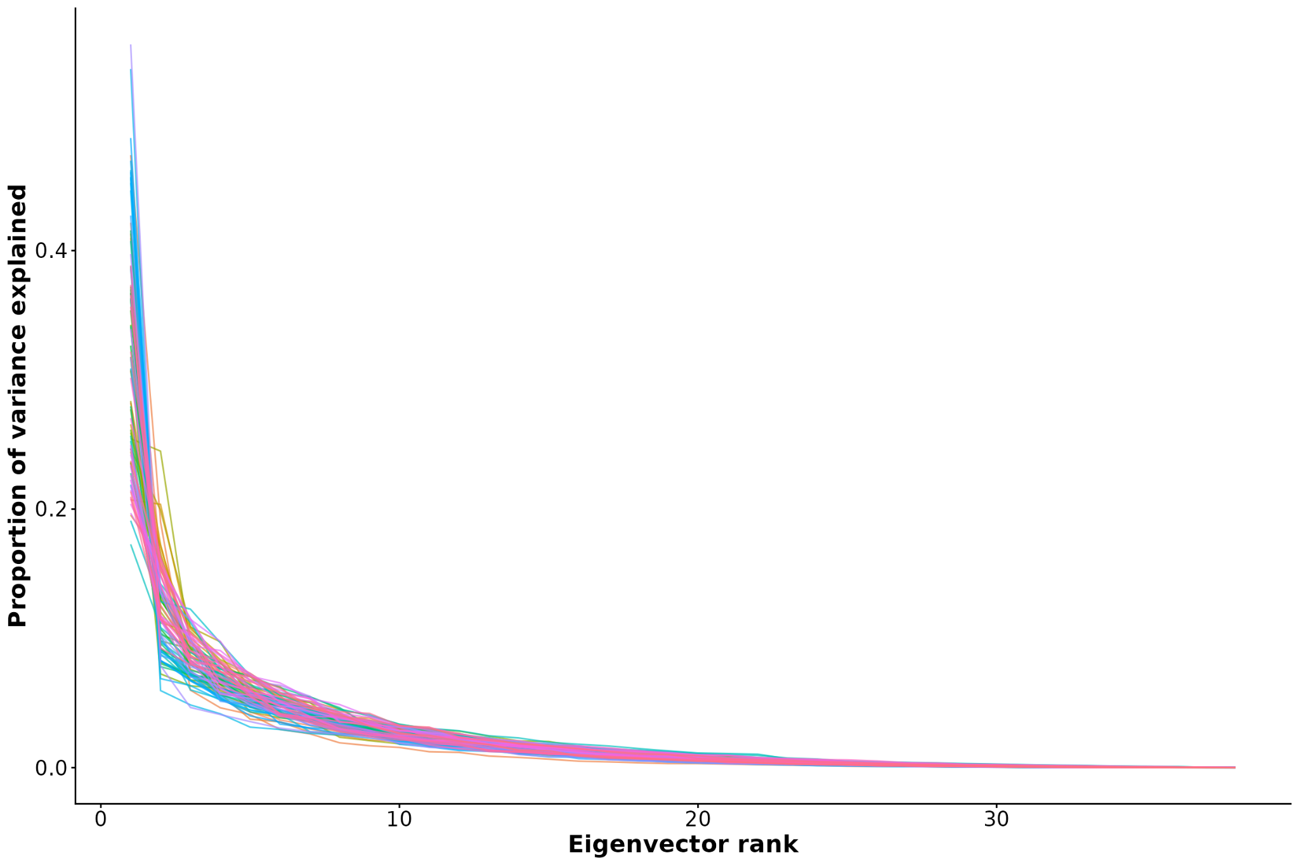
Figure 1: Proportion of phenotypic variance explained by each rank (eigenvector) of the phenotypic covariance (P) matrices across simian species. Most phenotypic variation is concentrated in the first ranks, whereas the last ranks explain only a small fraction of the total variance. This distribution helps identify the directions of morphospace that capture the greatest amount of variation, while lower-ranked directions are expected to be more susceptible to uncertainty arising from P matrix estimation.

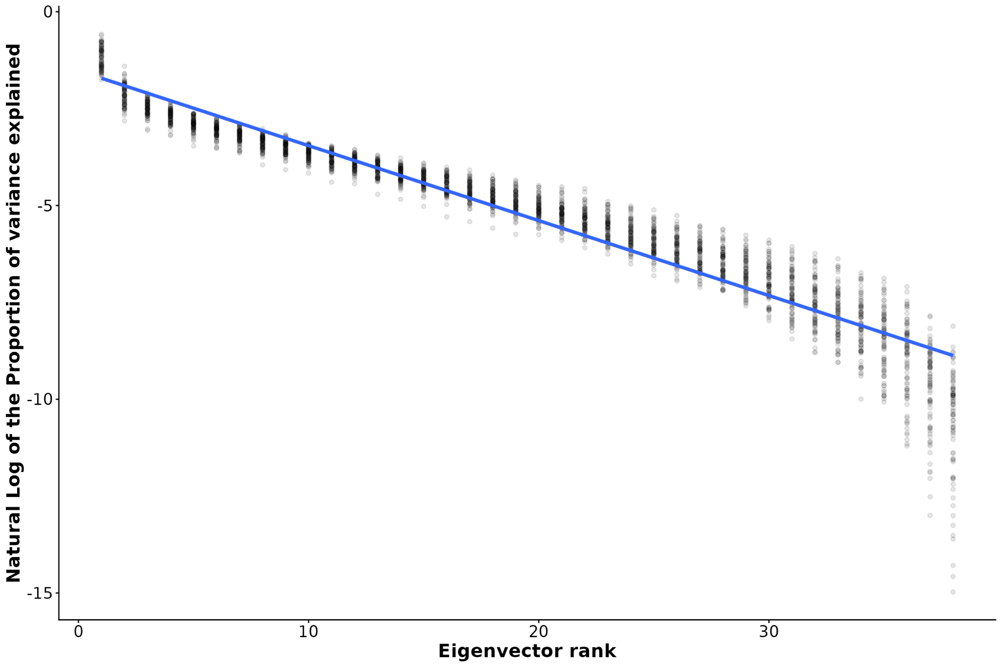
Figure 1.2: Natural logarithm of the proportion of phenotypic variance explained by each eigenvector rank of the phenotypic covariance (P) matrices across simian species. On the logarithmic scale, the decline in variance explained is approximately linear, indicating that the contribution of successive eigenvectors decreases exponentially with rank. The persistence of this pattern suggests that the lower-ranked components explain only a negligible fraction of the total variance and are therefore more susceptible to estimation uncertainty. The blue line represents the fitted linear regression (R² = 0.913). LINES.

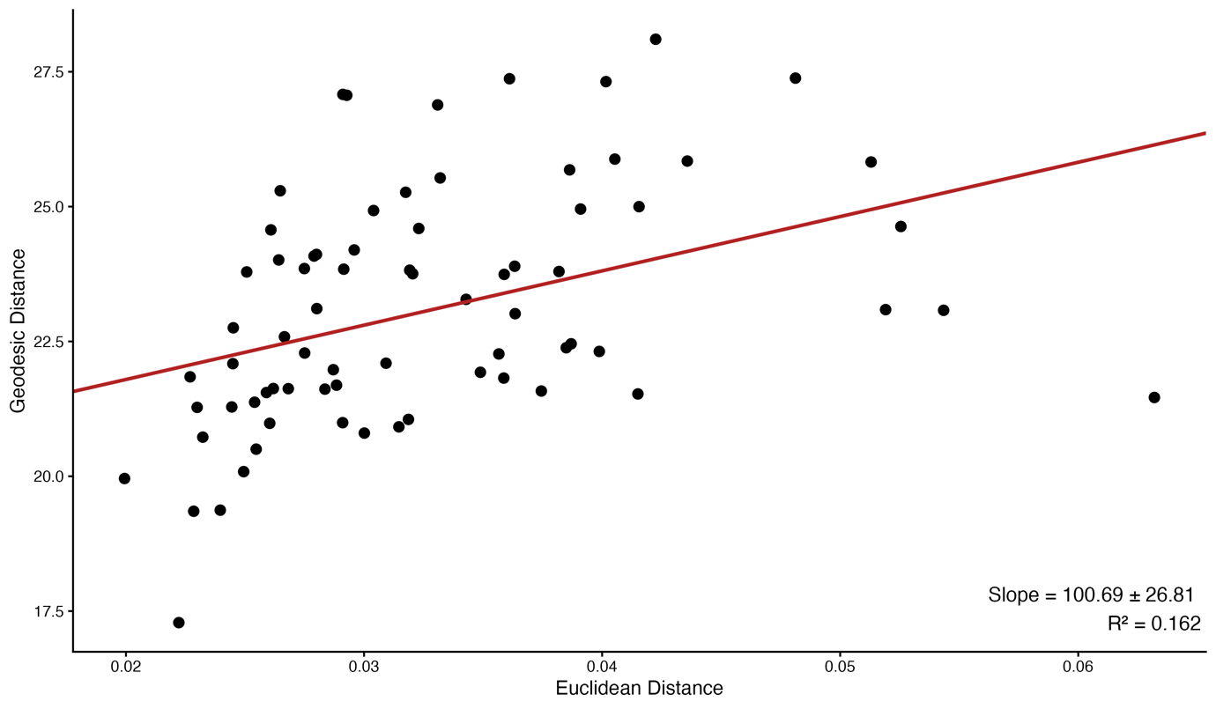
Figure 2: Relationship between the distance of species-specific P matrices from the mean P matrix, quantified as geodesic distance, and morphological divergence, quantified as Euclidean distance from the global mean shape. All variables were log-transformed, and the size component (Pmax, corresponding to the first eigenvalue of each P matrix) was removed prior to analyses. The regression line represents the phylogenetic Ornstein–Uhlenbeck model fitted using SLOUCH, which estimated a stationary variance of 4.152 and a phylogenetic half-life of 1.421 Myr.

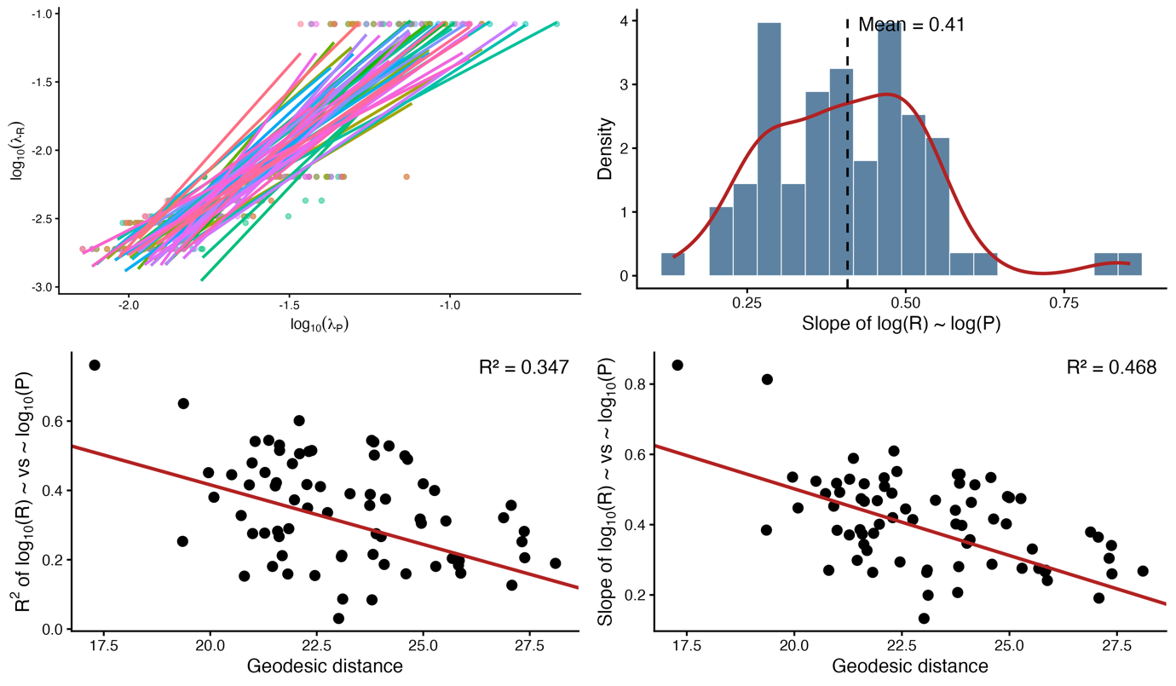
Figure 3: Relationship between phenotypic (P) and evolutionary (R) variance structures across species. (A) Scaling relationships between eigenvalues of species-specific P matrices and the eigenvalues of the evolutionary variance matrix (R), shown on a log10 scale. Each line represents the linear regression between the six eigenvalues of R and the corresponding eigenvalues of a species-specific P matrix. (B) Distribution of the scaling slopes obtained from species-specific regressions between log10-transformed diagonal elements of R and P matrices. The dashed line indicates the mean slope across species. (C–D) Relationships between geodesic distance of species-specific P matrices from the mean P matrix and the scaling properties of R-P relationships. (C) Relationship between geodesic distance and the coefficient of determination (R²) of log10(R) ~ log10(P) regressions. (D) Relationship between geodesic distance and the slope of log10(R) ~ log10(P) regressions. The fitted SLOUCH models were: R²(R–P) = −0.0344 (±0.0054) × Geodesic distance + 1.1036 (±0.1296) and Slope(R–P) = −0.0379 (±0.0047) × Geodesic distance + 1.2604 (±0.1114) for panels C and D, respectively.

Note: The analysis corresponding to Figure 4 in the original manuscript was not performed because it requires the genetic covariance (G) matrix. At present, only phenotypic covariance (P) matrices are available for the simian dataset, preventing the estimation of evolutionary correlations between variances in G.
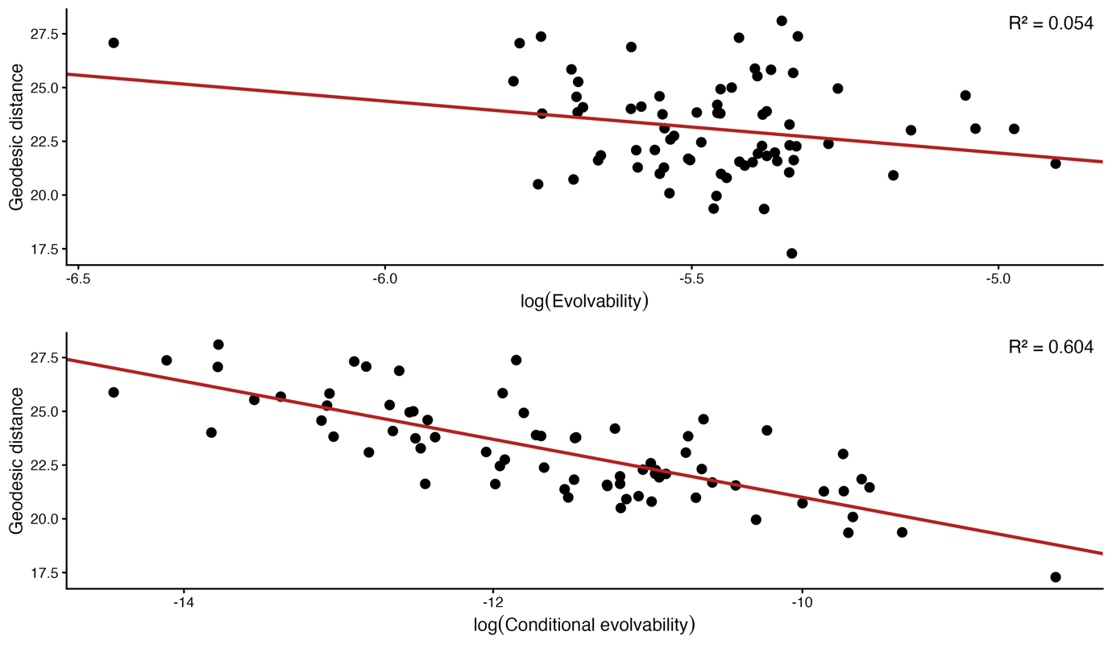
Figure 5: Relationship between distance of species-specific P matrices from the mean P matrix and evolvability. Relationships between geodesic distance and log-transformed mean evolvability (A) and log-transformed mean conditional evolvability (B) are presented. Regression lines and R² values were obtained from phylogenetic Ornstein–Uhlenbeck models fitted using SLOUCH, accounting for phylogenetic non-independence and measurement error through a direct-effect model. (A) Geodesic distance = −2.4132 × log(Evolvability) + 9.8902 and (B) Geodesic distance = −1.3487 × log(Conditional evolvability) + 7.5141
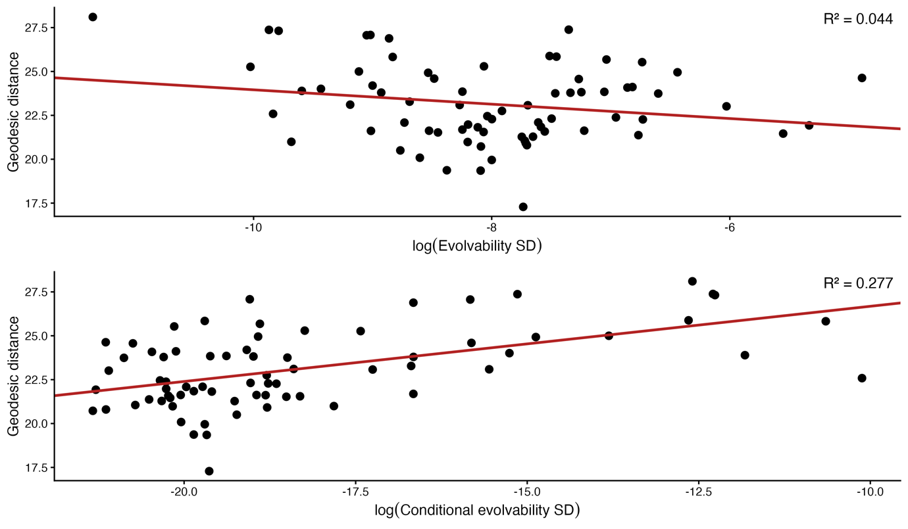
Figure 5.2: Association between P-matrix divergence and the capacity for evolutionary change along the sexual dimorphism axis. Geodesic distance of species-specific P matrices from the mean P matrix was evaluated against log-transformed evolvability (A) and log-transformed conditional evolvability (B) for the sexual dimorphism vector. Regression lines and R² values were obtained from SLOUCH phylogenetic Ornstein–Uhlenbeck models using a direct-effect model correcting for phylogenetic non-independence and measurement error. (A) Geodesic distance = −0.4094 × log(Evolvability SD) + 19.8620 and (B) Geodesic distance = 0.4284 × log(Conditional evolvability SD) + 30.9648.

